**Import Your Teacher Schedule into Google Calendar**

## Overview

School faculty should have their academic and advisory schedule imported into their primary Google calendar. This facilitates intraschool scheduling by correctly displaying faculty free/busy times for other parties to consider when creating a meeting invitation.

## Step 1 - Download the Import File Created for You by the School

1. [**Click here**](https://drive.google.com/) **[update link!]** to open in a new tab a Google Drive folder containing your import file.
2. Find the import file that is assigned to you by name and **double-click** it to preview the events that will be imported.
3. Scroll through the events list and verify that it looks correct.
   1. If there is an issue, do not go further and contact the IT helpdesk.
4. At the **top-right** of the window, click the **download icon** (  ) to download the import file to your **Downloads** folder.

## Step 2 - Import the Downloaded File into Your Google Calendar

1. Navigate to the **Calendar Import Page**: [**https://calendar.google.com/calendar/r/settings/export**](https://calendar.google.com/calendar/r/settings/export)
   1. Log into your LFCDS Google account if prompted.
2. Under **Import** click **“Select file from your computer”**.
3. Find the downloaded import file in your **Downloads** folder, select it, and click **Open**.
4. **Important:** Under **“Add to calendar**” make sure that the calendar selected is your primary calendar that is in the **“FirstName LastName”** format. You do not want to accidentally import *all your classes for the entire term* into another calendar. Additionally, for others to see your availability, your class schedule must be in your primary (“FirstName LastName”) calendar.
5. Click the **Import** button and wait while your events are imported into your calendar. It can take up to 30 seconds.  
   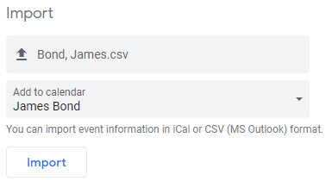
6. Once the events are imported you will receive a confirmation prompt. Click **OK**.  
   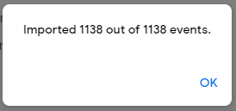
7. At the **top-left** of the window, click the **back arrow** (  ) to view your calendar.
8. Verify that the events were imported correctly and are displaying from your primary Google calendar.